Laguna honda hospital

replacement program

BI Monthly Status Report

Presented to THE

Citizens’ General Obligation Bond Oversight committee

february 2013

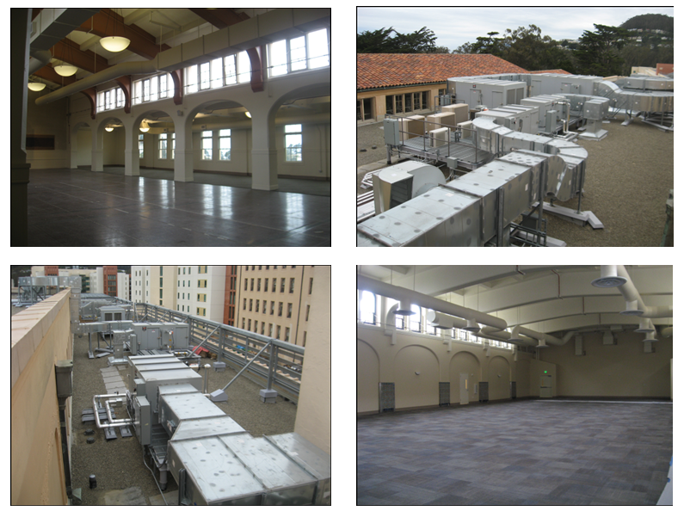

presented by

John Thomas, Program Manager, 557-4668, [john.thomas@sfdpw.org](mailto:john.thomas@sfdpw.org)

Laguna Honda Hospital Replacement Program

# table of contents

**Executive Summary**

Program Status Page 1

**Program Summary**

Program Background Page 2

Program Budgets and Funding Page 3

Program Appropriations Page 4

**Project Status Summary** Page 5-7

**Appropriations, Encumbrance and Expenditures Report**  Page 8-11

**Encumbrance Schedule**  Page 12

**Cash Flow Schedule** Page 13

**Gantt Chart** Page 14-17

**Executive Summary**

The new building contracts were closed out and final payment was made on December 2012. The Program has two major phases remaining. The first, already underway, is the completion of the remodel of Wing H which will be discussed in more detail below. The second is the abatement, demolition and final site work. In order to simplify the closeout process, the project team has split the CM-at-Risk contract into two contracts, the first related to the new buildings and associated site work, and the second for the remodel work. This allowed the previously mentioned closeout of the new building contracts and simplified administering the Remodel contract.

As of December 2012, the remodel is approximately 86% complete. By the end of February 2013, the HVAC, electrical, plumbing, sprinklers, and interior walls and sheetrock, painting, and ceilings were complete, with the exception of Simon Auditorium and the Laguna Honda Chapel. The H wing energization is roughly complete, with the exception of Simon Auditorium and the Chapel. The ‘cutover’ of power of A and B Wings to the power from the new buildings, is not expected to be completed until June 2013, due to unexpected field conditions and OSHPD regulatory requirements. The HVAC system balancing was 99% complete as of February 2013.

The Medical Clinic renovations were completed in November. Client requests for new lighting in Administration received OSHPD approval in December and we expect final OSHPD sign-off for Administration by the end of March 2013. Once completed, Administration can reoccupy their offices.

Turner submitted a revised schedule at the beginning of March 2013, and it is still being reviewed and negotiated.

# PROGRAM SUMMARY

**Program Background**

The Laguna Honda Hospital (LHH) Replacement Program comprises demolition, construction, and renovation of LHH, including (a) the construction of three new buildings: South, Link, and East; and (b) renovations to existing facilities. The LHH Replacement Program will result in 780 Skilled Nursing Facility beds for an estimated cost of completion of $584,946,602.

On November 2, 1999, San Francisco voters approved Proposition A, a ballot measure authorizing the City and County of San Francisco (City) to issue up to $299,000,000 in General Obligation Bonds to finance the LHH Replacement Program. In addition to the $299,000,000 principal amount authorized in the General Obligation Bonds, the DPW is able to use interest earned from the General Obligation Bonds, to finance the LHH Replacement Program. The total interest earned, between May 2005 through March 2008, from the investment of the $299,000,000 in General Obligation Bonds is $26,771,514, and has been appropriated by the Board of Supervisors.

In addition to using General Obligation Bonds and General Obligation Bond Interest Earnings to finance the LHH Replacement Program, Proposition A also allows the DPW to use Tobacco Settlement Revenue funds, which are funds received under a 1998 Master Settlement Agreement between the Attorney General of the State of California and various manufacturers of tobacco products. This agreement is administered by the State of California, and total tobacco funds received to date for the Replacement Program is $140,992,731.

**Program Budgets and Funding**

**Funding**

The following is a summary of the funding sources identified for the Replacement Program by the Controller and the Mayor’s Office of Public Finance:

|  |  |
| --- | --- |
| **Sources of funding for LHH Replacement Program** | |
| General Obligations Bonds(1) | 296,083,671 |
| Interest Earned from General Obligation Bonds | 26,771,514 |
| Tobacco Settlement Revenues(2) | 133,554,943 |
| Interest Earned from Tobacco Settlement Revenues | 7,437,788 |
| Certificates of Participation | 120,000,000 |
| Grants(3) | 1,098,686 |
| **Total** | **584,946,602** |
|  |  |
| (1) - General Obligation Bonds approved by the San Francisco voters on November 2, 1999. | |
| (2) - Tobacco Settlement Revenues are funds received under a 1998 Master Settlement Agreement between the Attorney General of the State of California and various manufacturers of tobacco products, which is administered by the State of California. | |
| (3) - Grants are from the US Health Resources and Service Administration (HRSA) and the US Department of Housing and Urban Development (HUD). | |

**Appropriations**

Listed below is the reconciliation between the Controller’s Office and DPW’s accounting as of February 28, 2013.

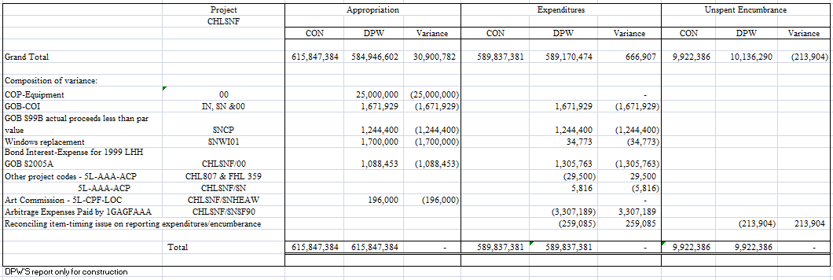

The appropriation amount from the Controllers’ Office includes the project’s budget of $584,946,602; $25,000,000 for the FF&E; $1,700,000 for windows replacement to the old buildings; $1,088,453 reserve for arbitrage for 1999 LHH GOB S2005A; $2,916,329 for GOB cost of issuance and actual proceeds less than par value; and transfer of $196,000 LHH 2-D Fund to LHH account per Public Art Commission. The total appropriation reported by the Controller’s Office is $615,847,384.

The expenditure amount from the Controller’s Office includes the project’s expenditures of $589,170,474, bond interest of $1,305,763, windows replacement of $34,773, DPH Oversight management fee of $5,816, and GOB actual related costs of $2,916,329. It does not include $29,500 for the Utilities Modification Project and the Access & Signalization Projects. There is difference of $259,085 due to timing for reporting expenditure. The total expenditure reported by the Controllers’ Office is $589,837,381.

The encumbrance amount from the Controller’s Office is $9,922,386.

**Project Status Summary**

**Laguna Honda Program Replacement Program**

**Project Location:** 375 Laguna Honda Boulevard, San Francisco, CA 94116

**Project Manager:** John Thomas;

[John.Thomas@sfdpw.org](mailto:John.Thomas@sfdpw.org); (415)557-4668

**Project Description:**

Construction of the Link, South, and East buildings; and the new hospital site improvement have been completed in December 2010.

Remodel of the existing Hospital began in June 2007. This work continues in phases in order to minimize the impacts to the operating Hospital.

The remodel project has taken over all of H and the old Medical Clinic, except for the Sherriff’s office. The H-Wing hazardous materials abatement was 95% complete by the end of June 2012, and Turner has completed most hard and soft demolition activities on H-3. H-2 was taken over by the Remodel several months ahead of schedule for abatement and soft demolition and was mostly complete as well; Material’s Management and Material’s Handling were relocated to L-3. The Sheriff’s Office was supposed to be relocated in mid to late April, but the separate and unrelated remodel for the Sheriff’s Office is behind schedule.



|  |  |
| --- | --- |
| Project Budget |  |
| Original Budget | 401,600,000 |
| Current Budget | 584,946,602 |
| Current Projected | 584,946,602 |
| Actual Expenditures | 566,441,561 |

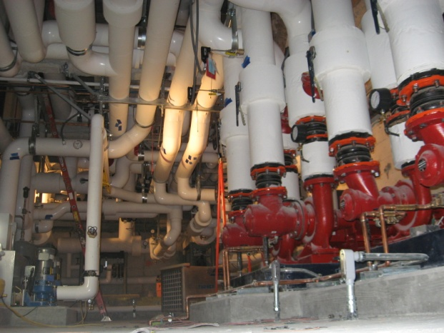

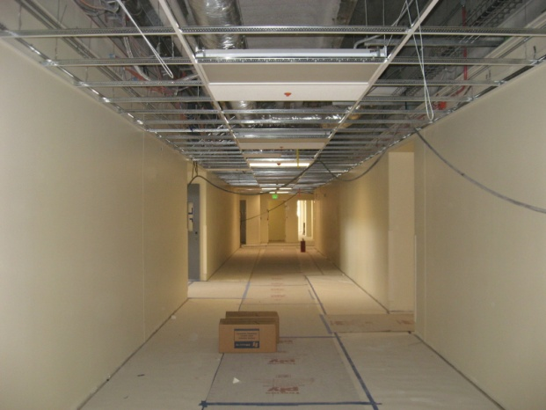

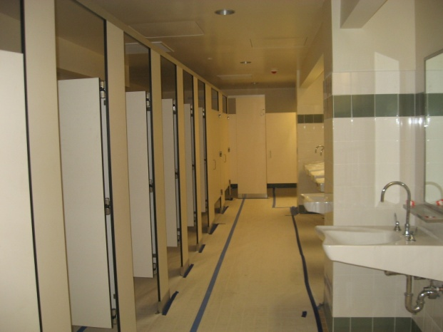

**Change Order Status**

The following table provides a breakdown of change orders executed to date for the program. Client requests include items such as: 1) the addition of ‘resident laundry’ rooms on each floor for personal belongings, 2) adding ‘bed exit’ monitoring ports to 562 patient rooms (in addition to the 218 originally scoped, 3) adding bed pan washers in each patient bedroom (360 bathrooms), additional cooling at each IT distribution and server room to address cooling requirements from the latest equipment.

Major site condition change orders include: coordination for mechanical, electrical and plumbing, exterior waterproofing changes, building and site security. In addition, there have been several change orders which transferred work planned for future phases to the current phase, including the construction of a temporary loading dock and a canopy for the permanent loading dock work, and additional parking lot and road lighting in order to have a more complete and functional facility while the final phases are under way.

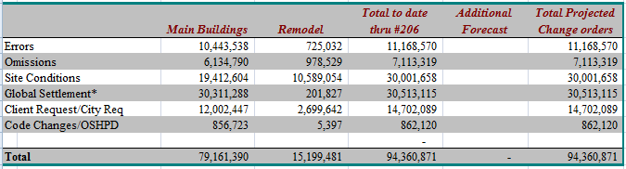

* On December 12, 2011, the City and County of San Francisco filed a lawsuit in San Francisco Superior court against Stantec Architecture, Inc., and related entities, seeking recovery of damages for breach of contract, professional negligence, and indemnity, and seeking declaratory relief related to a dispute arising from the design and construction of the Laguna Honda Replacement Project.  The complaint is available for review.

**Forecast**

The forecast cost at completion for the 780 bed project and associated Remodel work is $584,946,602.

The structural repairs for Wing H, mentioned in the previous report, were complete as of February 2013. The deficient structural concrete repairs, in addition to other issues, has resulted in the Replacement team, in conjunction with hospital staff, agreeing to delete Remodel scope and site improvement scope. The Project Team completed the drawing revisions incorporating the eliminated scope to reduce the cost of construction on the remodel portion of the work by $9 million. Work in Wing C has been eliminated and the work in H wing, level 3 has been simplified through the deletion of support space for Adult Day Health Care and substitution of open office space for the private office space originally planned. The revised plans were approved by OSHPD in July 2011.